实 验 报 告

课程名称： 模型驱动的软件开发技术

学 院： 计算机科学与工程学院

专 业： 软件工程 班 级： 软件18-1班

姓 名：KAFLE SAMRAT学 号： 201801060933

2020年 11月 09日

山 东 科 技 大 学

实 验 报 告

页

|  |  |  |  |  |  |
| --- | --- | --- | --- | --- | --- |
| 组 别 |  | 姓 名 | KAFLE SAMRAT | 同组实验者 |  |
| 实验项目  名称 | * [综合案例分析实践总结](javascript:void(0)) | | 实验日期 | 2020.11.09 | |
| 教师评语 |  | | | | |
| 实验成绩： | | | 指导教师（签名）：  年 月 日 | | |

**car rental system**

This system divides 3 use case diagrams according to the function.

(1) Customer use case diagram: mainly describes the customer's registration, the modification of customer information, and the content that needs to be completed when the customer borrows and returns the car. For example, if a customer books a car by phone or online, the customer can inquire about the information of the car, return the car with a balance and pay a deposit if the car breaks down.

(2) System maintenance personnel use case diagram: describes the maintenance and management of the system by the system maintenance personnel, including the management of employee information, administrator login to the system, user level setting, user information query and user logout.

(3) Technical personnel use case diagram: it describes the functions of the technical personnel to modify the vehicle information, add the vehicle information, delete the vehicle information and so on. Before modifying the vehicle information, the system will inquire the vehicle information to be modified, and after modifying, deleting, adding and other operations, the system will save its data.

Use-case diagrams relevant to the customer

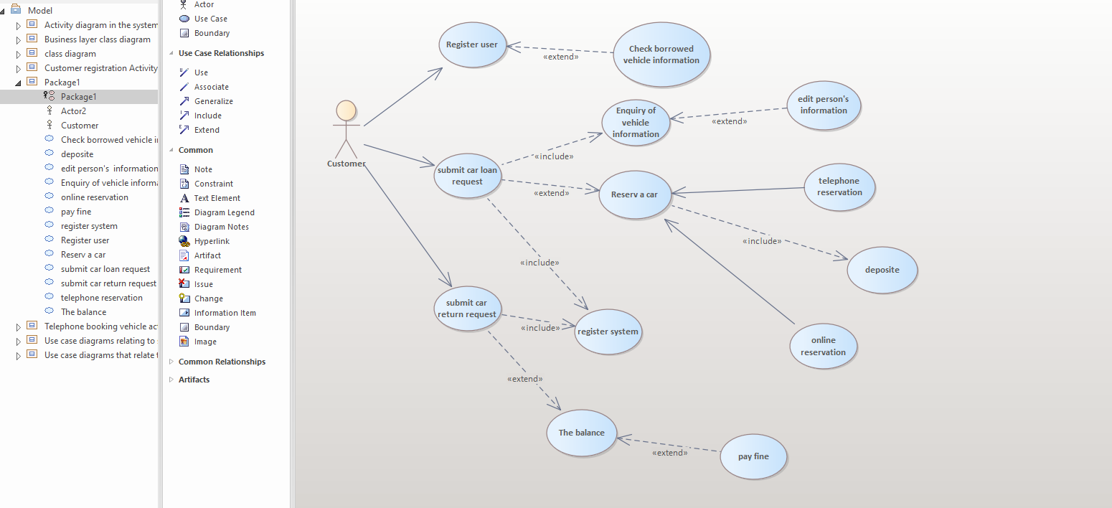

(1) User registration case is used for the customer registration system, which is convenient for the future rental of vehicles and the presentation and certification of their own relevant information, and convenient for those who have never entered the system to enter the system for the first time.

(2) The car loan case is used for the whole process from car selection to car picking from the customer who hires a car from the company.

(3) Transfer case, used for customer record of vehicle return information.

(4) The use case of vehicle information query is used for customers to query vehicle information, and the system displays vehicle information.

(5) The vehicle reservation case, which is used when the customer does not confirm the vehicle rental at that time. Customers can book by phone or online.

(6) Balance use case, which is used to facilitate the customer to inquire about the balance of the car and facilitate the completion of the transaction.

(7) Telephone booking use case, used to facilitate the customer needs to book a car, but for some reason can not book in person, need to book a car by telephone.

(8) Online booking use case, used to facilitate customers to book vehicles online, reduce the trouble of car booking.

(9) Penalty payment case, which is used to pay the penalty when the customer violates the agreement, safeguard the legitimate interests of the company, and enhance the customer's safety awareness.

(10) Query return time use case, used for the customer when he forgot when he should return the car, query return time, convenient to remind the customer to return the car in time.

(11) Logon system use case, which is used to facilitate the logon of customers who do not log in to the system for operation.

(12) Cancellation use case, where the customer can cancel or replace the reserved vehicle after booking and within two days before actual use.

(13) Deposit case, used for customers to pay deposit when borrowing or booking vehicles, to strengthen the company's management of vehicles and customers.

(14) The use case of inquiring the borrowed vehicle information, which is used for the customer to inquire the borrowed vehicle information after borrowing the vehicle.

(15) The use case of modifying personal information is used to modify the relevant information of customers when their personal information changes for the convenience of management.

Use case diagrams relating to system maintainers

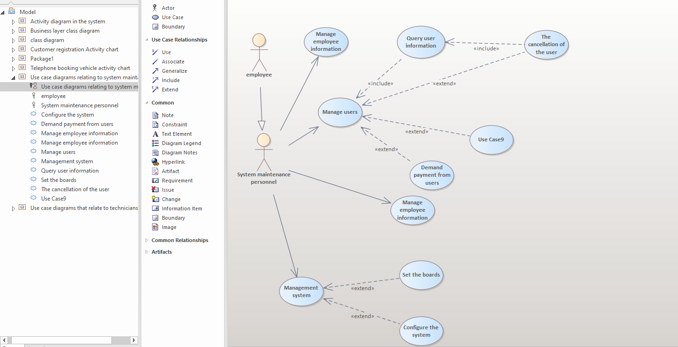

(1) Manage user use cases, which are used for system maintenance personnel to manage customers' basic information, frequently borrowed models, contact information and whether they have rented vehicles.

(2) Administrator login case, which is used for the system maintainer to log in the system as administrator (the permissions are different from the login of employees and customers).

(3) Use case for management of employee information, which is used for system maintenance personnel to manage the basic information, department, work done, work performance and contact information of employees.

(4) Logout user use cases, used for the system maintenance personnel to delete the information of customers with bad records or quit the customer information of the system for other reasons.

(5) Query user information use case, used for system maintenance personnel to query all user information according to relevant content, so as to facilitate the management of user information

(6) Set the user level use case, which is used for the system maintainer to set the access rights of users and facilitate the management of users.

(7) Call the customer's money case, which is used for system maintenance personnel to call the customer's money and remind the customer to return the car when the actual amount of money that the user needs to pay is more than the deposit and the user's car is overdue.

(8) Management system use case, used for system maintenance personnel to manage the system.

(9) Set up the version area use case, used for system maintenance personnel to set the system interface, so that the system interface is clean and beautiful.

(10) Configure the system use case, used for the system to maintain the basic information of the personnel configuration system, so that the system has the basic structure and function.

Use case diagrams that relate to technicians

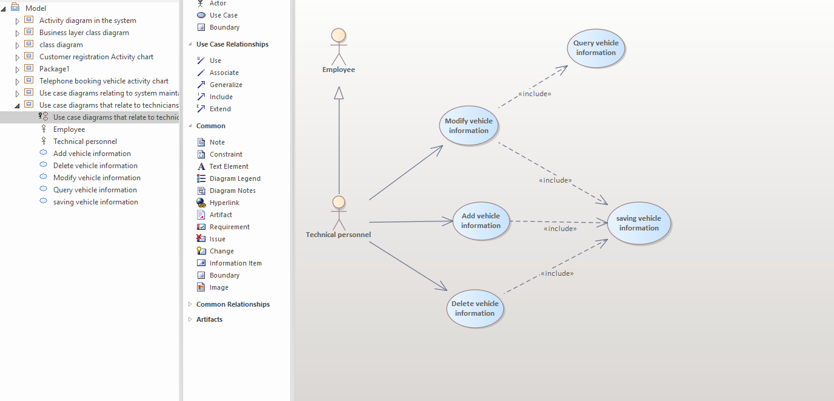

(1) The use case of modifying vehicle information, which is used for technicians to modify the vehicle information and display the modified vehicle information when necessary.

(2) The use case of vehicle information query is used for the technical personnel to check the vehicle condition before and after the user borrows and changes the vehicle.

(3) Add vehicle information use case, used for technicians to add information to new vehicles or vehicles with other conditions when needed.

(4) The use case of deleting vehicle information, which is used for technicians to delete the scrapped vehicle or some information that the vehicle itself no longer has when needed.

(5) The use case of saving vehicle information is used for technicians to save the information after modifying, adding and deleting the vehicle when necessary, so as to track and understand the vehicle situation in the future.

Class diagram design modeling

The system is divided into two class diagrams according to functions and modules.

Data access layer class diagram: it mainly describes the relationships among various types in the database, including entity class of basic employee information, entity class of basic customer information and entity class of basic vehicle information. The relationship between the specific categories is shown in Figure 9e2.5 data access layer class diagram.

Business layer class diagram: mainly describes the relationship between the business layer of, mainly in staff management entity, login system entities, entities registered entity class, interface Settings, user level set of entities, entities borrow the car, car entity, booking entity class and query of the vehicle vehicle information entity class and so on. The relationship between the specific categories is shown in Figure 9e2.6 business layer class diagram.

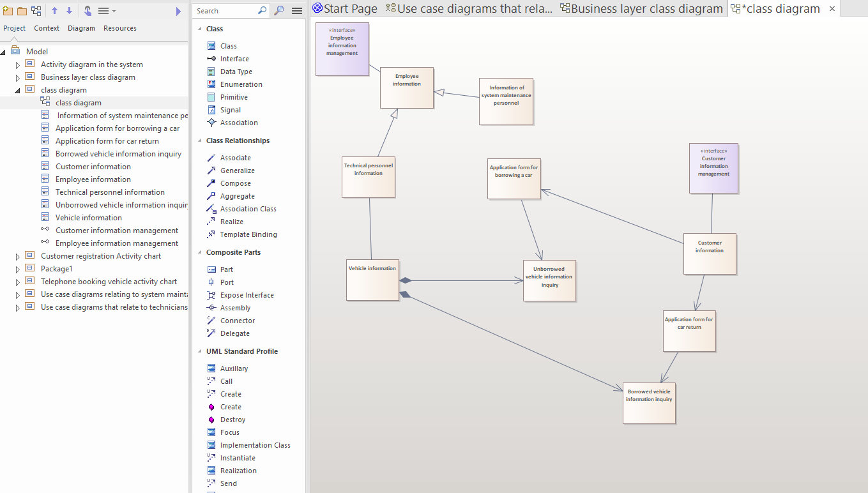

(1) Basic information of employees: It is used to store basic information of employees and facilitate the management of employees of the company.

(2) Basic information of technicians: It is used to store basic information of technicians and is easy to manage.

(3) Basic information of system maintenance personnel: It is used to store the basic information of system maintenance personnel and is convenient for management.

(4) Basic vehicle information: it is used to store vehicle information, so that customers can inquire about the vehicle and employees can manage the vehicle conveniently.

(5) Customer basic information: It is used to store customer basic information and facilitate the system maintenance personnel to manage employees.

(6) Application form for car loan: It is used to store the information of customer's application for car loan and enable employees to manage the car loan according to this database.

(7) Vehicle return Application Form: It is used to store the information of customer's vehicle return application, so as to facilitate the management of vehicle return by employees.

(8) Basic system information of the unborrowed vehicle: It is used to store the information of the unborrowed vehicle, and the unborrowed vehicle needs to be inquired before the application is approved.

(9) Basic information of the borrowed vehicle: It is used to store the information of the borrowed vehicle. The borrowed vehicle needs to be inquired before the application is processed to facilitate the balance.

Business layer class diagram

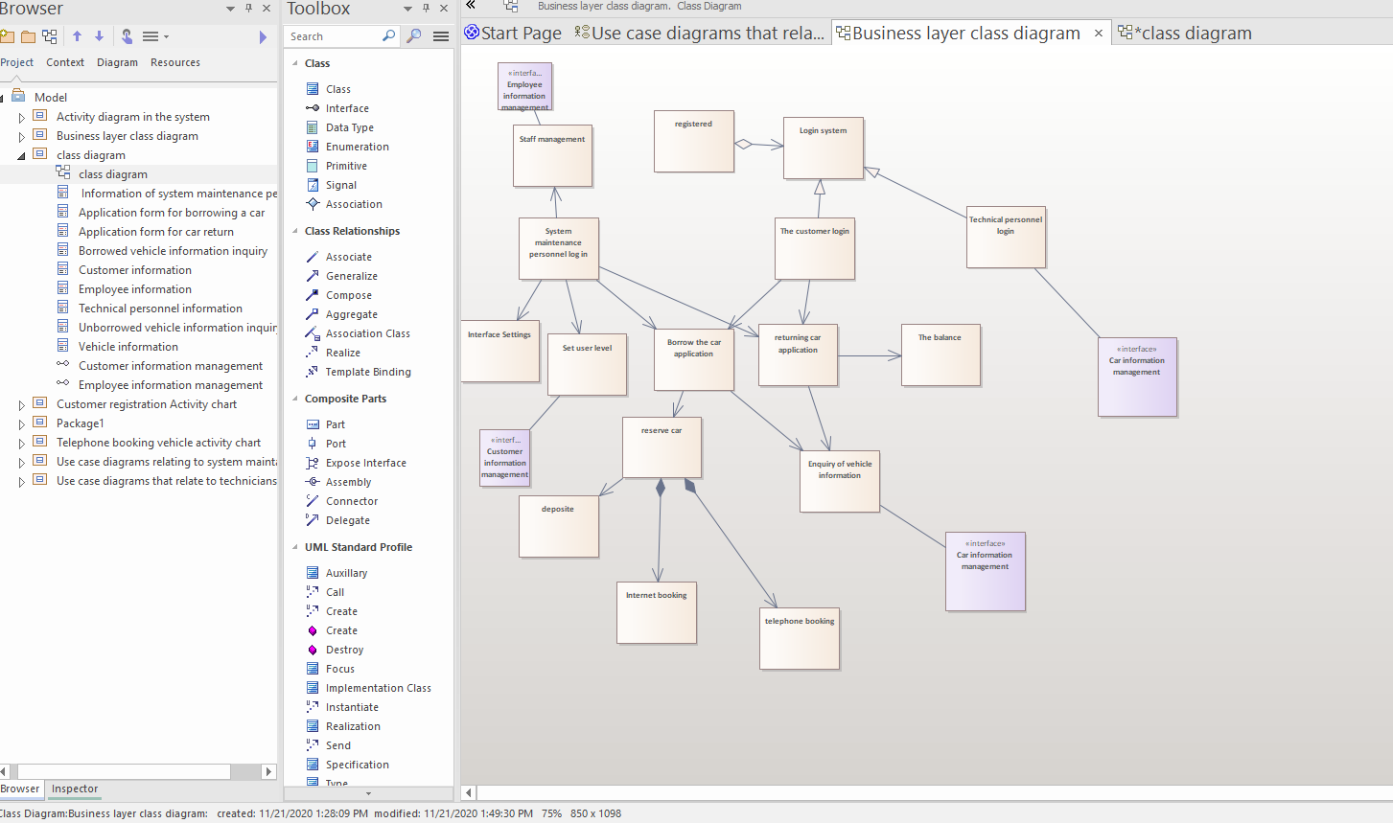

(1) Management staff: This type is used for system maintenance staff to query and modify employee information.

(2) Registration class: This class is used to register information for customers and employees that have not yet been registered.

(3) Login system class: This class is used for customers and employees to login the system.

(4) System maintenance personnel login class: Used for system maintenance personnel login system.

(5) Customer login class: Used for customer login system.

(6) Technical personnel login class: Used for technical personnel login system.

(7) Interface setting: The system maintenance personnel shall set the interface to make the system interface more beautiful.

(8) Setting user level class: The system maintenance staff sets the level of customers to facilitate the management of users.

(9) Application for car loan: Customers should apply for car loan before they borrow the car, and fill in the information of car loan when they borrow the car, so as to facilitate the management of system maintenance personnel.

(10) Application for vehicle return: Customers should apply for vehicle return before returning the car, which is convenient for employees to manage the vehicle.

(11) Vehicle reservation: Customers reserve the vehicle before borrowing the vehicle, and employees can borrow the vehicle according to the information of the reserved vehicle.

(12) Vehicle information query: The customer needs to query the vehicle information to be borrowed and returned before borrowing and returning the vehicle.

(13) Deposit: The customer must pay the deposit after borrowing the car.

(14) Online booking: Customers can book vehicles online.

(15) Telephone booking category: customers book vehicles by telephone.

(16) Balance category: Customers should make balance when returning the car.

Activity diagram in the system

According to the function of this system can be divided into 10 activity diagrams, namely technical personnel management vehicles activity diagrams, customer query information activity diagrams, customer registration activity diagram, system maintenance personnel management, employee information activity diagram, activity diagram, telephone booking vehicle online booking car vehicle activity diagrams, still apply for the activity diagram, system maintenance personnel management user information activity diagram, system maintenance personnel management system, activity diagram, worth money activity diagram.

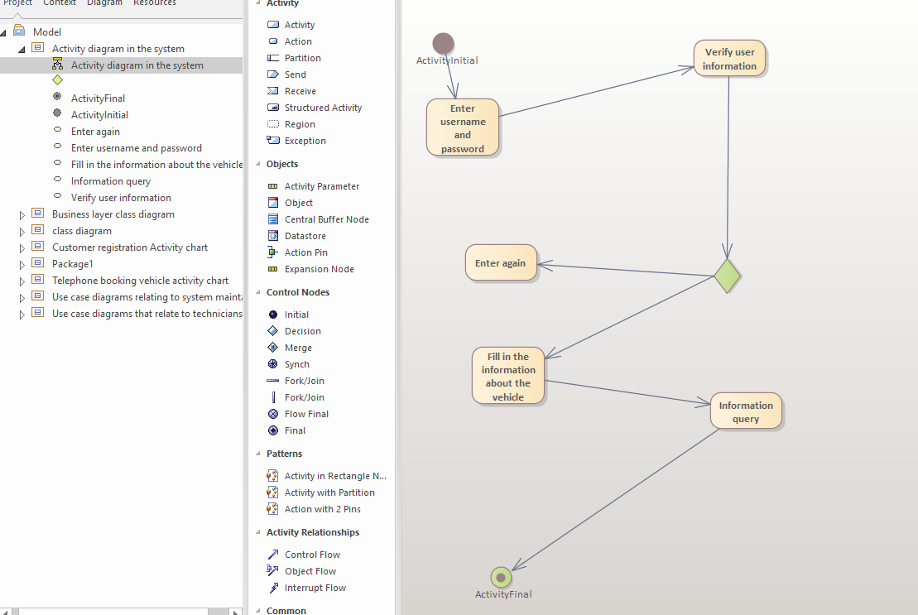

1. Enter username and password: Users must enter username and password to log in.

2. Verify user information: Check whether the user name and password match.

3. Re-enter: If the user name and password do not match, the user will be prompted to re-enter.

4. Fill in the relevant information of vehicle query: the vehicle information can be inquired after logging in.

5. Information query: Information query connected to the system

Customer registration Activity chart

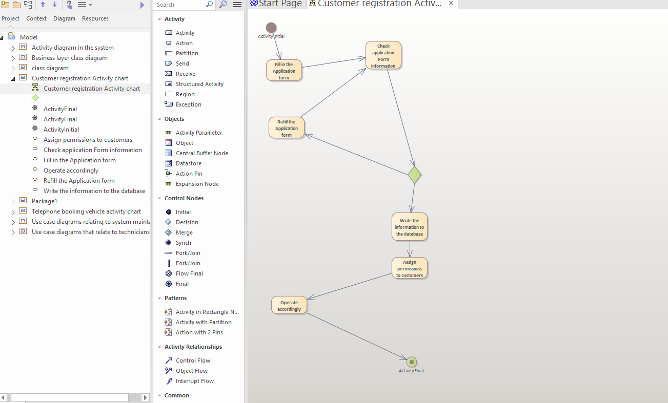

1. Fill in the Application form: The user fills in the application form and makes application.

2. Check application form information: the system checks whether the application form information is correct.

3. Fill in the application form again: if the information in the application form is incorrect, it will be prompted to fill in the application form again.

4. Write the information into the database: save the information of the approved application form into the database.

5. Assign privileges to customers: assign privileges to customers for queries.

Telephone booking for vehicle activities diagram

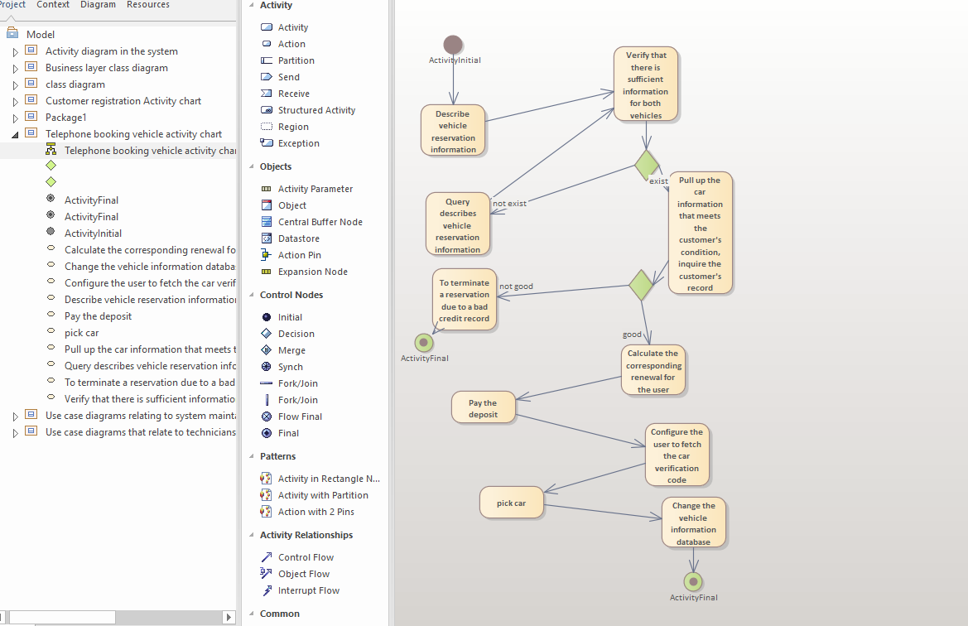

1. Describe the vehicle reservation information: describe the vehicle reservation information.

2. Query description reservation vehicle information: Query required vehicle description information.

3. To terminate a reservation due to a bad credit record: the act of terminating a reservation due to a low credit score.

4. Calculate the corresponding renewal for the user: give the corresponding renewal for the applied user.

5. Deposit: prompt the user to submit the corresponding deposit.

6. Configure the vehicle verification code for users: The system will configure the corresponding vehicle verification code for users.

7. Car picking: The user picks up the car.

8. Change the vehicle information database: After taking the vehicle, the system changes the vehicle information.

online Book vehicle activities diagram:

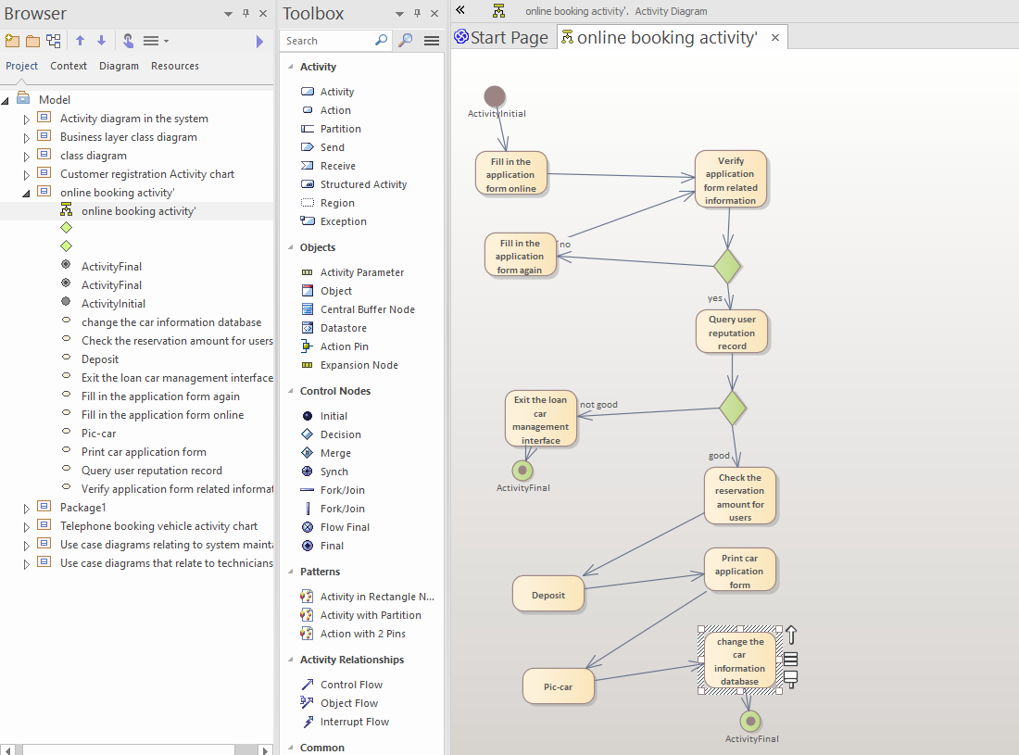

1. Fill in the car loan application form online: The customer fills in the car loan application form online.

2. Verify the information of application form: The system maintenance staff verifies the information of user application form.

3. Fill in the application form again: if the application form is wrong, the user will fill in the application form again.

4. Query user reputation record: System maintenance personnel query user loan task record.

5. Exit the loan management interface: if the user does not have a good loan record, exit the loan management interface.

6. Calculate the reservation amount for the user: if the user has a good record of borrowing the car, calculate the reservation amount for the user.

7. Deposit: The user borrows the car to pay the deposit.

8. Print application form for car pickup: System maintenance personnel print application form for car pickup.

9. Take out the car: The user takes out the car.

10. Change the vehicle information database: The system maintenance staff changes the vehicle information database.

Return car application activity chart

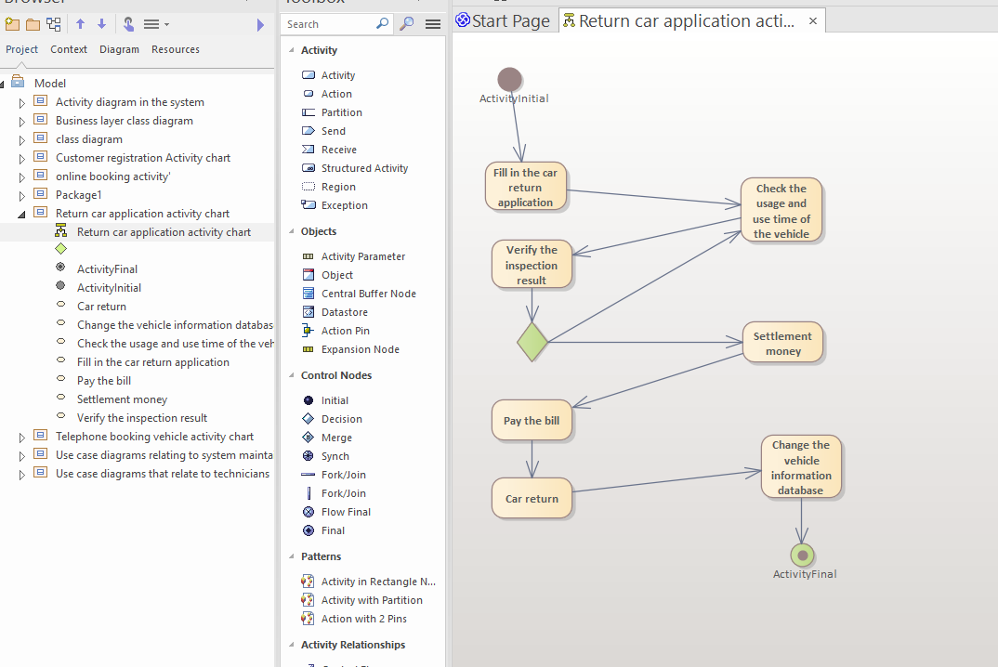

1. Fill in the car return application: the user fills in the car return application.

2. Check the usage and use time of the vehicle: System maintenance personnel check the usage and use time of the vehicle.

3. Verify the inspection result: the user verifies the inspection result and the settlement account is in conformity.

4. Settlement money: settlement money for system maintenance personnel.

Pay the bill: The user pays the bill.

6. Car return: the user returns the car.

7. Change the vehicle information database: The system maintenance staff changes the vehicle information database.

System maintainers manage employee information activities

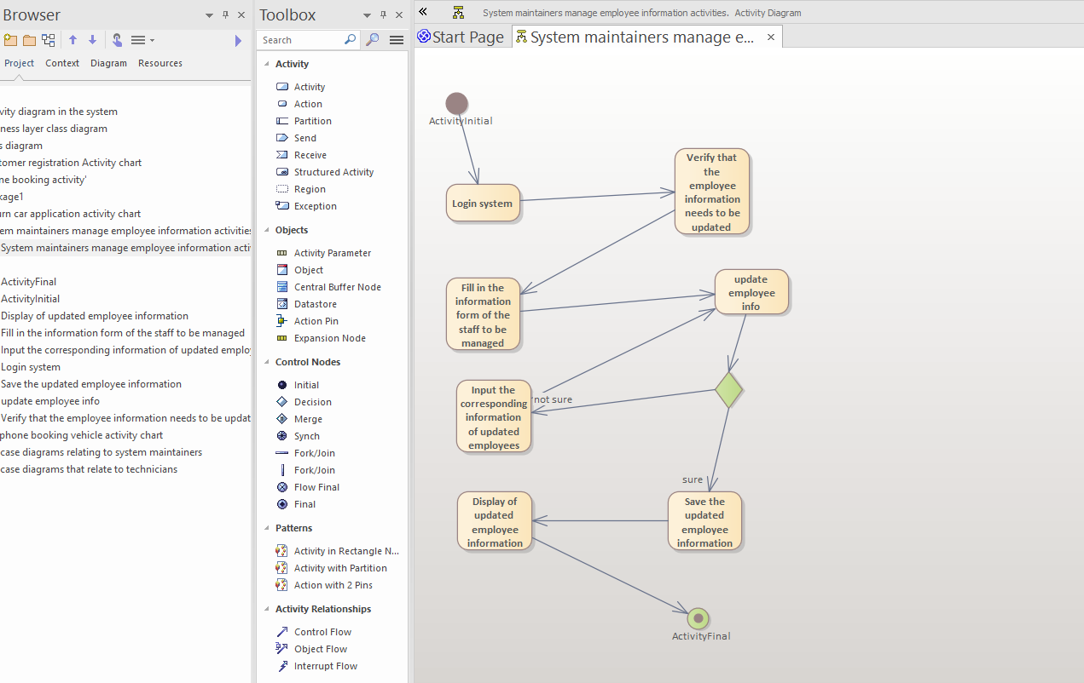

1. Login system: The user logs in the system.

2. Fill in the information form of the staff to be managed: fill in the information of the staff to be managed in the form of the form.

3. Verify that the employee information needs to be updated: Verify that the user information that needs to be updated is correct.

4. Input the corresponding information of updated employees: If the verification is passed, input the information of updated employees.

5. Fill in and update the employee information again: if the verification fails, it will be prompted to fill in again.

6. Save the updated employee information: save the customer information after input.

7. Display of updated employee information: When updating employee information, the system will prompt.

summary

The management automation system of a car rental company is used to manage various businesses of the company and to retrieve a large amount of information about customers, vehicles and employees. Taking this system as an example, this chapter explains the analysis and design process of the car rental system in detail. Through this example, readers can fully understand and grasp the power and flexibility of UML graphical modeling language.

The use case diagram, class diagram, activity diagram are used in the analysis and design of the cases in this chapter. Through the use of these diagrams, readers can master the application methods of VARIOUS UML diagrams in system analysis and design.